CHAPTER III

Technicality of the Project
This chapter discusses the technical complexity of PH VibeCheck AI as an end-to-end pipeline for continuously collecting Philippine online news, processing it with NLP, and presenting the outputs through interactive dashboards. The technicality of the project lies not in a single algorithm, but in the coordination of multiple subsystems that must operate reliably under real-world constraints (dynamic websites, changing page structures, continuous scheduling, and reproducible storage). The system transforms unstructured, web-delivered articles into structured analytical outputs (sentiment and entity signals) that can be queried, aggregated, and verified through an interactive interface.

System Architecture Overview
The system is designed as an end-to-end pipeline for automated news collection, processing, and visualization. The frontend is implemented as a Next.js web application deployed on Vercel. The backend provides a REST API implemented using FastAPI and is deployed within a Docker environment.
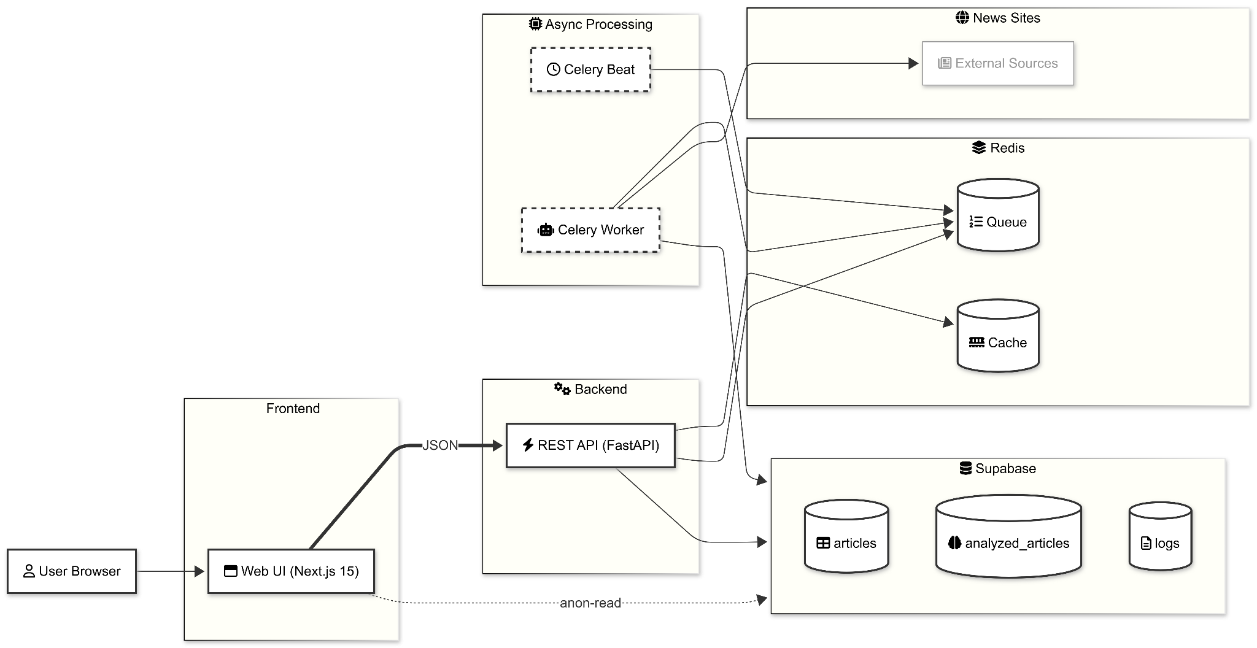
Figure 2. System architecture of PH Vibe Check AI
As shown in Figure 2 The system follows a three-layer architecture. The frontend layer, built with Next.js, renders interactive dashboards and communicates with the backend through analytics endpoints (e.g., ml, articles), while also supporting direct reads from Supabase for selected data views. The backend layer, implemented in FastAPI, manages application logic, handles API requests, and coordinates data persistence through Supabase, while Redis supports caching and asynchronous task management.
The background processing layer is responsible for continuous data ingestion and analysis. Celery Beat schedules scraping tasks at defined intervals, while Celery workers execute both web scraping and Natural Language Processing (NLP) tasks. The results of these processes are stored in structured database tables (e.g., raw_articles, analyzed_articles, and scraping_logs), enabling downstream analytics and dashboard visualization.

Technology Stack Roles (Subsystem View)
The system adopts a modular architecture in which each technology is assigned a clearly defined role within the overall pipeline:
Web/API Layer (FastAPI): Provides RESTful endpoints for dashboard data access and operational controls, including manual triggering of scraping and system-level functions.
Containerized Deployment (Docker): Ensures consistent runtime environments across all components, including the API, Celery workers, scheduler, and supporting services.
Task Scheduling and Background Execution (Celery & Celery Beat): Celery workers handle asynchronous execution of web scraping and machine learning tasks, while Celery Beat manages periodic scheduling for data collection across multiple sources.
Queueing and Caching Layer (Redis): Acts as the message broker and result backend for Celery. It also provides lightweight caching capabilities for frequently accessed analytical results to improve system responsiveness.
Relational Storage Layer (Supabase PostgreSQL): Stores normalized articles and processed outputs in structured form. The schema is designed with stable upsert mechanisms, allowing updates or rescoring of records without duplication.
Frontend Analytics Interface (Next.js): Provides an interactive dashboard for visualization, filtering, and drill-down analysis, enabling users to explore sentiment trends and verification results.

Single-Article Pipeline Flow (From URL to Dashboards)
While the architecture is multi-component, the system can be understood most concretely as the lifecycle of a single article.
Discovery (per source): the scraper seeds candidate URLs (HTTP section pages, RSS feeds, or JSON endpoints depending on the outlet), then canonicalizes and de-duplicates the URL set.
DB preflight de-duplication: candidate URLs are checked against existing rows in the articles table so that already-ingested URLs are skipped early during continuous runs.
Content extraction (fast-path to fallback): the scraper attempts network-first extraction (structured data / site JSON payloads). If content is incomplete or blocked, the scraper falls back to Playwright rendering and then extracts the final text.
Normalization and storage: the extracted article is normalized into a consistent schema (source/category fields, content cleaning, and timezone-aware published_at), then inserted into Supabase (PostgreSQL). URL canonicalization and insertion safeguards prevent duplicate rows from silently accumulating.
Asynchronous ML enqueue: after storage, the pipeline enqueues analysis for new article IDs on the ML queue, decoupling heavy NLP work from scraping and from API response latency.
Sentiment + entity extraction: the ML worker fetches the stored article text and runs (a) hybrid sentiment scoring and (b) named entity recognition, producing per-article outputs plus metadata that supports auditing and reproducibility.
Upsert analysis outputs: analysis rows are upserted into analyzed_articles using a stable uniqueness key so re-scoring overwrites rather than duplicates. A public-facing cache table (article_sentiment_public) is also upserted to support lightweight frontend display and fast reads.
Aggregation and visualization: API endpoints compute trend/correlation/entity summaries from stored outputs (with optional Redis caching for repeated queries), and the frontend renders the results as dashboards for monitoring and drill-down.

Web Scraping Under Real-World Website Constraints
Modern news sites vary in how content is delivered: some pages can be discovered and parsed reliably via HTTP requests, while others require additional steps due to dynamically rendered content, anti-bot protections, or frequent layout changes. For these reasons, scraper implementation must be resilient and modular.
The system implements multiple news sources as separate scraper modules (backend/app/scrapers/), enabling per-source adaptation without destabilizing the overall pipeline. Where necessary, headless browser automation can be used to render dynamic pages before extraction. This flexibility is important for long-running monitoring systems because website structures evolve continuously.

Multi-Source Adaptive Scraping Framework
To support reliable and scalable data collection from heterogeneous Philippine news platforms, the system implements a multi-source adaptive scraping framework. This framework generalizes the scraping process across multiple providers while allowing source-specific optimizations to handle variations in website structure, content delivery mechanisms, and anti-bot protections.
The framework follows a network-first, browser-fallback design, balancing efficiency and robustness under real-world conditions.

General Pipeline Design
The scraping process is structured into three primary stages: discovery, extraction, and fallback handling.
Network-first discovery. The system prioritizes lightweight discovery of article URLs using non-rendered sources such as HTTP-based section listing pages, RSS feeds, and public JSON or API endpoints. This approach minimizes computational overhead by avoiding unnecessary browser automation during the initial stage.
Network-first extraction. Once candidate URLs are identified, the system attempts direct content extraction using structured metadata (e.g., JSON-LD NewsArticle), embedded JSON payloads, and static HTML parsing. This improves throughput and reduces the likelihood of timeouts during large-scale ingestion.
Browser fallback mechanism. When network-based extraction fails due to dynamic rendering, incomplete content, or access restrictions, the system falls back to Playwright-based browser automation. This ensures reliable content retrieval for JavaScript-heavy or protected pages. To maintain efficiency, fallback execution incorporates optimizations such as selective resource blocking and configurable execution modes (headless or headed).

Deduplication and Preflight Validation
To prevent redundant processing, all discovered URLs undergo canonicalization and early deduplication. A database preflight check verifies whether an article already exists in the dataset before processing. This prevents duplicate storage and reduces unnecessary computation during continuous ingestion cycles.

Source-Specific Adaptations
While the general pipeline remains consistent, the framework incorporates source-specific adaptations to handle platform-level constraints.
ABS-CBN. ABS-CBN presents challenges related to dynamic content delivery and anti-bot protections. To address this, the system applies a multi-stage strategy that includes API-based discovery using OneDomain endpoints, supplemented by RSS feeds when necessary. Content extraction prioritizes structured metadata (e.g., JSON-LD), with fallback to Playwright rendering when required. Additional optimizations, such as resource blocking and optional headed execution, are used to improve reliability on protected routes.
GMA News Online. For GMA News Online, the system leverages structured data endpoints to maximize efficiency. Candidate URLs are discovered through HTTP section pages, while article content is retrieved through a story-level JSON API when available (e.g., data.gmanetwork.com). When extraction is incomplete, the system falls back to Playwright rendering. This layered approach is particularly effective for high-volume ingestion scenarios such as historical backfilling.
The adaptive scraping framework enables efficient and scalable data collection across multiple sources. By prioritizing network-based methods and reserving browser automation as a fallback, the system reduces computational overhead while maintaining robustness against structural changes and access restrictions. Additionally, isolating source-specific logic improves maintainability, allowing individual scrapers to be updated without affecting the overall pipeline.

Asynchronous Processing and Scheduling
One of the key technical design decisions in this system is the separation of web scraping and NLP analysis from the API request–response cycle. Executing these operations synchronously, such as extracting multiple articles or processing long-form text with NLP models, would significantly degrade system responsiveness. To address this, the system employs Celery workers to handle scraping and machine learning tasks asynchronously, with redis as the message broker to decouple computationally intensive asynchronous tasks from synchronous API interactions, thereby preserving dashboard responsiveness under ingestion load
Task scheduling is managed using Celery Beat, which enables continuous and automated data ingestion. Scraping tasks are executed at predefined intervals per news source, allowing the system to maintain an up-to-date dataset without requiring manual intervention. This design supports steady-state operation and ensures that the platform provides a continuously refreshed view of news data.
To improve system efficiency and workload isolation, the task queue is divided into separate processing channels. Scraping tasks are assigned to a dedicated scrape queue, while sentiment analysis and entity extraction tasks are routed to a separate machine learning queue. This separation prevents computationally intensive NLP tasks from delaying data ingestion and allows for independent configuration of concurrency limits and restart policies for each worker group.
Scraping schedules are configured per source to balance data freshness with responsible access patterns. High-frequency sources may be scheduled at shorter intervals, while sources with stricter access constraints are scheduled more conservatively. In such cases, tasks can be routed to specialized worker configurations, including browser-based execution modes when required for reliable content retrieval.
From an operational perspective, asynchronous execution also improves system resilience. If a scraping task encounters timeouts or temporary source failures, retry mechanisms can be applied without affecting other tasks in the queue. Meanwhile, the API remains responsive, as it serves preprocessed data from the database rather than waiting for scraping or analysis tasks to complete.

Storage, Upserts, and One Active Sentiment Row per Article
Operational stability in the system depends on well-defined and consistent storage semantics. News articles are stored as normalized records in Supabase (PostgreSQL), while sentiment analysis outputs are written using upsert operations to ensure that reprocessing or rescoring does not introduce duplicate entries that could distort analytical results.
Sentiment outputs are stored in a dedicated table, analyzed_articles, using a composite key consisting of (article_id, model_version, model_type = 'sentiment'). This design ensures that each article has a uniquely identifiable sentiment record per model version. In addition, the system maintains a secondary table, article_sentiment_public, which serves as a lightweight cache for frontend consumption. This two-table approach supports both data protection and performance: internal analysis data can be secured using row-level security (RLS), while the public table enables fast and consistent reads for dashboard rendering.
At the storage boundary, the system incorporates several data integrity and consistency mechanisms that are critical for reliable trend analysis:
- URL canonicalization: Article URLs are normalized prior to insertion to eliminate trivial variations (e.g., tracking parameters), preventing duplicate records for the same content.
- Duplicate control at the storage layer: While early-stage deduplication is performed during scraping, the database layer enforces a second level of protection using upsert semantics and uniqueness constraints. This ensures that duplicate records are not inserted even in cases of concurrent ingestion, missed pre-checks, or retry operations.
- Timestamp normalization: When source timestamps lack explicit timezone information, publication times are normalized to UTC using an Asia/Manila assumption. This prevents systematic misalignment in time-based aggregations such as daily sentiment trends.
To maintain analytical consistency, the system enforces a single active model_version for production sentiment writes (e.g., sentiment_hybrid_v1). While multiple model versions may be recorded for experimentation, only one version is used in dashboard aggregation queries at a given time. This approach prevents double counting of sentiment outputs and ensures that reported metrics remain stable and interpretable.

Supabase Query Performance and Indexing (News-Scale Analytics)
Because the dashboard layer executes repeated queries over continuously growing article datasets, the system incorporates database indexing strategies tailored for news-scale workloads.
Full-text search (FTS) is implemented using a search_tsv column with a trigger-maintained tsvector, enabling efficient keyword search compared to naive substring matching. A language-agnostic simple configuration is used to support mixed Tagalog and English content.
To support substring-based queries, optional trigram indexing is applied using GIN indexes. This improves performance for ILIKE pattern matching at the cost of increased storage overhead.
For analytical queries, composite indexes are introduced to support common access patterns such as retrieving the latest sentiment per article and filtering data by source and date range for trend and correlation analysis.
All indexing operations are defined as executable SQL scripts (e.g., create_article_search_fts.sql, create_article_search_trgm.sql, and create_correlation_indexes.sql) to ensure reproducibility and consistent deployment across environments.

Hybrid Sentiment Engine (Implementation Technicalities)
PH VibeCheck AI employs a hybrid sentiment analysis approach to address the challenges of multilingual and code-switched Philippine news text. The system combines a lexicon-based sentiment analyzer (VADER) [11], extended with a Tagalog/Taglish lexicon, and a lightweight transformer-based classifier (DistilBERT) [6, 23] finetuned on SST-2 [24].

VADER: Long-Form Weighting for Articles
VADER is originally designed for short social media text, and its direct application to long-form articles can result in diluted sentiment signals. To address this, the system applies a long-form weighting strategy.
The article is divided into title and body components. The body is further segmented into sentence-level chunks. Sentiment scores are computed separately for the title, leading sentences, and remaining body segments. These scores are then aggregated using fixed weights to produce a single article-level compound score in the range [-1, 1].
Final sentiment labels (positive, neutral, or negative) are assigned using a configurable neutral band (VADER_NEUTRAL_BAND) to reduce false polarity in factual reporting.

PH Tagalog/Taglish Lexicon Patch
To improve performance on Philippine news text, VADER is extended using a versioned lexicon file (vader_ph_lexicon.v1.json). This patch includes Tagalog and Taglish sentiment expressions, conservative negation handling, and selected intensity modifiers.
Additionally, frequently occurring multi-word expressions are normalized into single tokens to ensure consistent scoring.
The lexicon patch is applied once per worker process, and its version is recorded in model metadata to ensure transparency and reproducibility.

DistilBERT: CPU Inference with Truncation and Neutralization
The transformer-based component uses DistilBERT for efficient sentiment classification on English-heavy text.
To maintain bounded execution time, the system enforces character clipping (DISTILBERT_MAX_CHARS) and token-level truncation (DISTILBERT_MAX_LENGTH).
Since the finetuned Distilbert is a binary classifier, neutrality is introduced through confidence-based thresholding (DISTILBERT_NEUTRAL_MIN_CONF). Predictions with low confidence are classified as neutral to avoid over-polarization.

Hybrid Routing Strategy
The system dynamically selects between the VADER+PH pipeline and the DistilBERT pipeline using a lightweight language heuristic.
Articles with strong Tagalog or code-switched signals are processed using the VADER-based approach, while predominantly English text is routed to the transformer model.
Routing decisions, along with model metadata, are stored to support traceability, auditing, and evaluation.

Dashboard Layer (Exploration and Verification)
The system provides an interactive dashboard interface to support monitoring, exploratory analysis, and qualitative verification of processed news data.
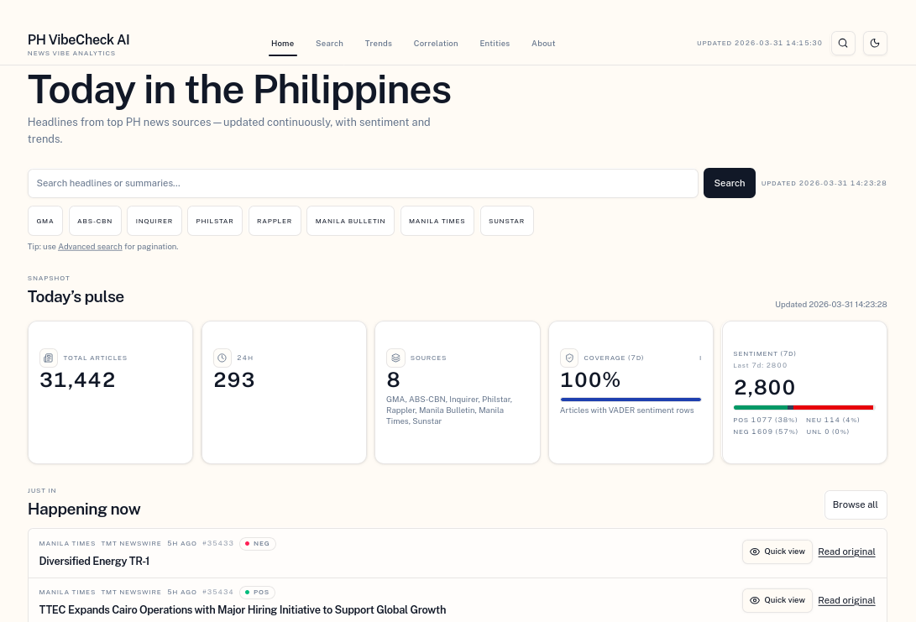
Figure 3. Main dashboard interface showing operational metrics and navigation to analytical modules.
Figure 3 shows the main dashboard interface, which serves as the primary access point for operational metrics and navigation to the system’s analytical modules.
Key dashboard modules include the following:
- Home: Displays recently ingested articles and summary operational metrics.
- Search: Enables keyword-based exploration with pagination and article-level inspection.
- Trends: Visualizes temporal changes in sentiment distributions over time.
- Correlation: Compares sentiment alignment across news sources using cross-source statistical analysis.
- Entities: Displays frequently mentioned named entities and associated aggregated sentiment scores.
These dashboard components are intended to support both high-level monitoring and drill-down verification, allowing users to inspect the underlying articles contributing to aggregated analytical outputs. The analytical results generated through the Trends, Correlation, and Entities modules are presented and discussed in detail in Chapter V.

